Name

Mathematics Stage 4
Converting Fractions Decimals Percentages

Book 1 | Identify and make use of the relationship  between fractions, decimals, and percentages  to carry out simple conversions | Version: 260409  Feedback:  https://MrDingMaths.com
Contents
Syllabus Content 2
Learning Intention 47

Syllabus Content
MA4-FRC-C-01 represents and operates with fractions, decimals and percentages to solve problems
Identify and make use of the relationship between fractions, decimals and percentages to carry out simple conversions
- Define rational numbers as numbers that can be written in the form $\frac{a}{b}$, where $a$ and $b$ are integers and $b≠0$
- Classify fractions and percentages as rational numbers
- Recognise and explain that numbers with terminating or recurring decimals are rational
- Represent fractions as decimals (terminating and recurring) and percentages
- Represent terminating decimals as fractions and percentages
- Represent improper fractions as mixed numbers and decimals, and vice versa
- Represent percentages as fractions and decimals

Mixed Numbers and Improper Fractions

- Types of Fractions
Proper Fraction | Improper Fraction | Mixed Numeral
$$\frac{3}{4}$$ | $$\frac{3}{3},\frac{4}{3}$$ | $$2\frac{1}{2}$$
Numerator $<$ denominator | Numerator $≥$ denominator | Integer with proper fraction
Less than one whole | One whole or greater | One whole or greater
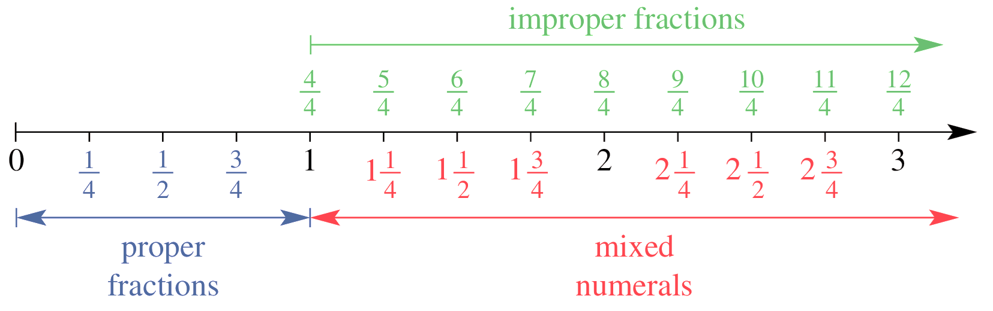

- Identify fractions as proper, improper, and mixed numerals
$$\frac{2}{3}$$  - Proper  - Improper  - Mixed Numeral | $$\frac{3}{2}$$  - Proper  - Improper  - Mixed Numeral | $$1\frac{1}{2}$$  - Proper  - Improper  - Mixed Numeral | $$\frac{99}{100}$$  - Proper  - Improper  - Mixed Numeral
$$\frac{99}{98}$$  - Proper  - Improper  - Mixed Numeral | $$-1\frac{9}{10}$$  - Proper  - Improper  - Mixed Numeral | $$-\frac{8}{12}$$  - Proper  - Improper  - Mixed Numeral | $$\frac{8}{8}$$  - Proper  - Improper  - Mixed Numeral

Foundation
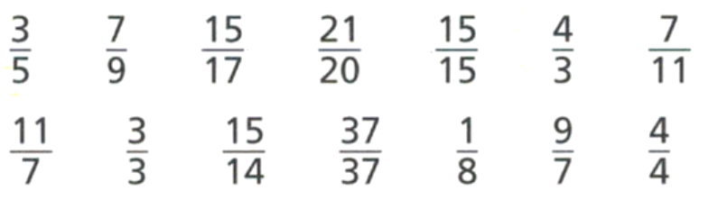
- Which of these fractions are less than one whole? How do you know?

$$\frac{3}{5},\frac{7}{9},\frac{15}{17},\frac{7}{11},\frac{1}{8}. The numerator is less than the denominator.$$
- Which of these fractions are equal to one whole? How do you know?

$$\frac{15}{15},\frac{3}{3},\frac{37}{37},\frac{4}{4}. The numerator is equal to the denominator.$$
- Which of these fractions are greater than one whole? How do you know?

$$\frac{7}{9},\frac{21}{20},\frac{4}{3},\frac{11}{7},\frac{15}{14},\frac{9}{7}. The numerator is greater than the denominator.$$
- Between which two whole numbers do these mixed numbers lie?
- $3$ $\frac{1}{2}$  3 and 4 | - $10$ $\frac{3}{7}$  10 and 11 | - $23$ $\frac{7}{22}$  23 and 24

- Write the mixed numbers at the marked points.
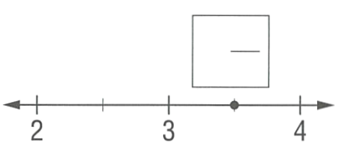  $$3\frac{1}{2}$$ | 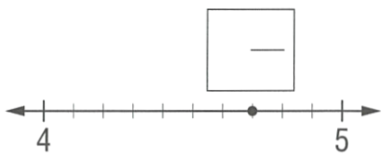  $$4\frac{7}{10}$$ | 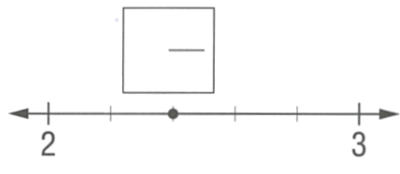  $$2\frac{2}{5}$$

- Consider the diagram:
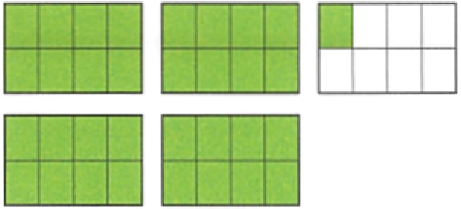
  - How many wholes are there in the diagram?
4
  - What does the diagram represent as a mixed numeral?
$$4\frac{1}{8}$$
  - How many eighths are shown in the diagram?
$$33$$
  - Write this as an improper fraction.
$$\frac{33}{8}$$

Development
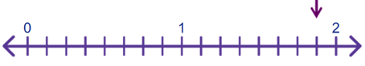
- Consider the number line:

  - What fraction does each interval represent?
$$\frac{1}{8}$$
  - What mixed number is the arrow pointing to?
$$1\frac{7}{8}$$
  - How many eighths is this?
$$15$$

- What mixed number is the arrow pointing at?
$$1\frac{5}{8}$$ | 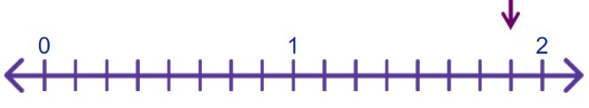  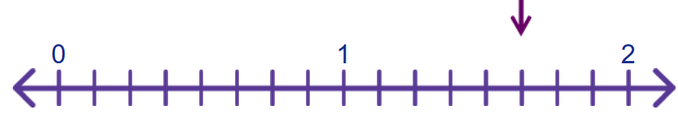  $$1\frac{7}{8}$$
$$2\frac{1}{5}$$ | 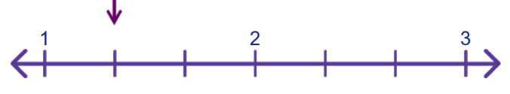  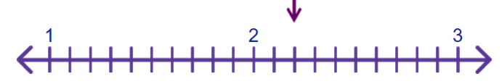  $$1\frac{1}{3}$$
$$2\frac{3}{5}$$ | 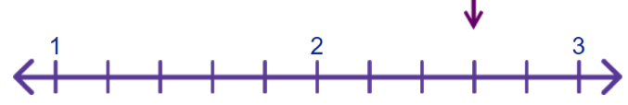  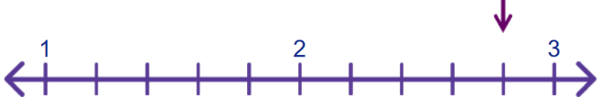  $$2\frac{4}{5}$$

- Identify the mixed numbers shown on these number lines.
$$7\frac{1}{2}, 10\frac{1}{2}$$ | 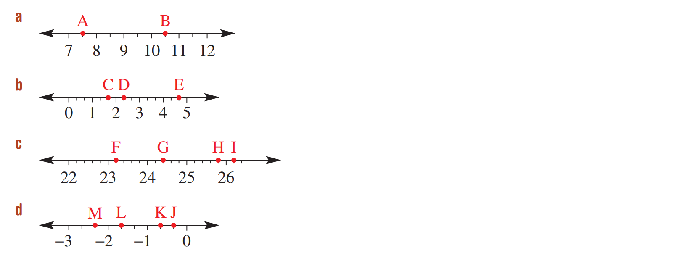  $$1\frac{2}{3}, 2\frac{1}{3}, 4\frac{2}{3}$$
$$23\frac{1}{5}, 24\frac{2}{5}, 25\frac{4}{5}, 26\frac{1}{5}$$ | $$-2\frac{1}{3}, -1\frac{2}{3}, -\frac{2}{3}, -\frac{1}{3}$$

Converting Mixed Numbers and Improper Fractions

- Mixed to Improper using Visuals
To convert mixed numbers to improper fractions:
- Split each whole into parts based on the denominator.
- Count the number of shaded parts.

- Example Convert mixed numbers to improper fractions visually
$$3\frac{1}{5}$$  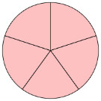  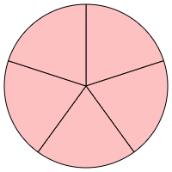  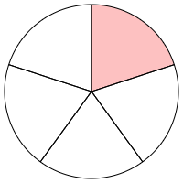  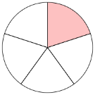  $$=\frac{16}{5}$$ | The denominator is ………, so we split each whole into ……… parts.

- Guided Practice
Convert these mixed numbers to improper fractions.
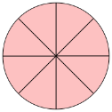  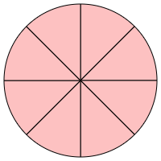  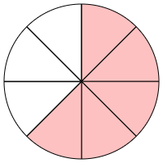  $$2\frac{5}{8}$$  $$=\frac{}{8}$$ | 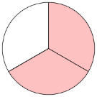  $$1\frac{2}{3}$$  $$=$$
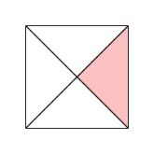  $$1\frac{1}{4}$$ | 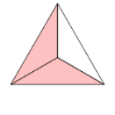  $$3\frac{2}{3}$$
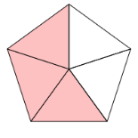  $$2\frac{3}{5}$$ | 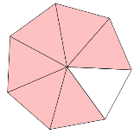  $$1\frac{6}{7}$$
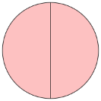  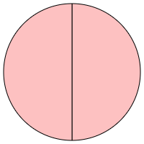  $$3$$  $$=\frac{}{2}$$ | 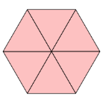  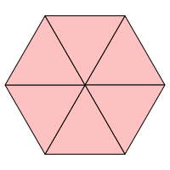  $$5$$  $$=\frac{}{6}$$

- Improper to Mixed using Visuals
To convert mixed numbers to improper fractions:
- Group parts into wholes.
- Count the wholes and leftover parts.

- Example Convert mixed numbers to improper fractions visually
$$\frac{5}{2}$$    $$=2\frac{1}{2}$$ | We combined the parts into 2 …………, and we had …… half left over.

- Guided Practice
Convert these improper fractions to mixed numbers.
- $\frac{7}{4}$  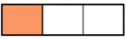   | - $\frac{8}{3}$
- $\frac{6}{2}$  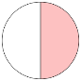  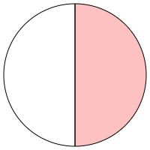  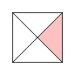  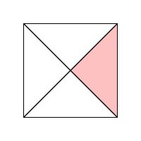 | - $\frac{12}{4}$

Foundation
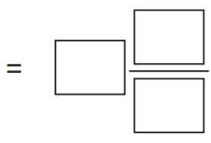
- Convert these fractions. Use the bar models to help you.
- $\frac{12}{5}$  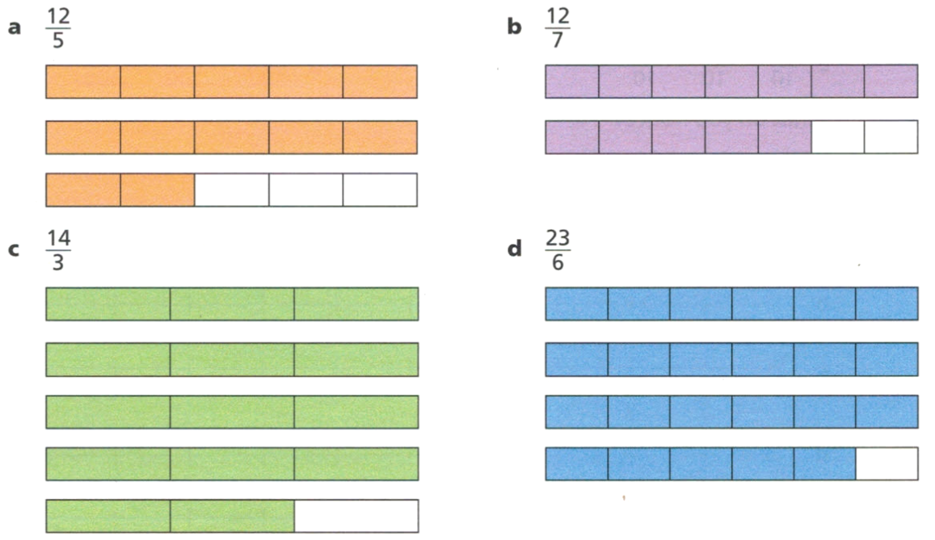  $$2\frac{2}{5}$$ | - $\frac{12}{7}$  $$1\frac{5}{7}$$ | - $\frac{23}{6}$  $$3\frac{5}{6}$$
- $1\frac{1}{8}$  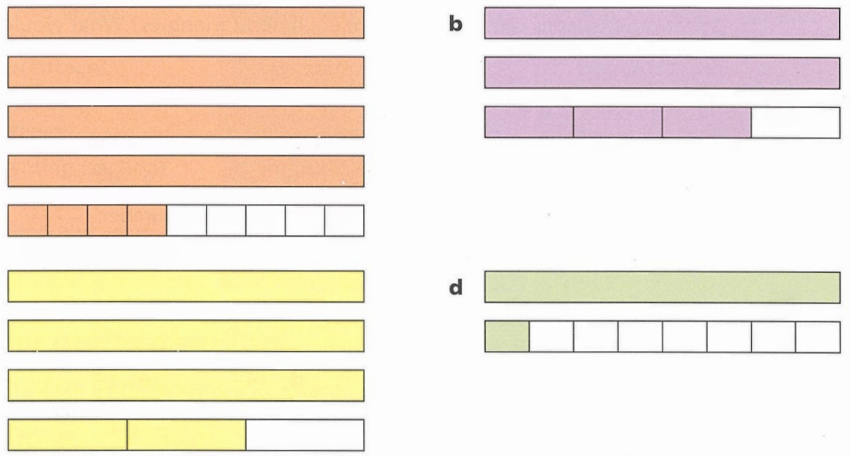  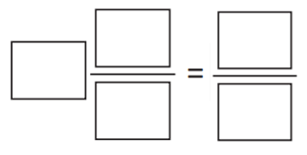  $$\frac{9}{8}$$ | - $3\frac{2}{3}$  $$\frac{11}{3}$$ | - $4\frac{4}{9}$  $$\frac{40}{9}$$

- For each of these diagrams, write the mixed numeral and the improper fraction.
$$1\frac{1}{2}=\frac{3}{2}$$ | 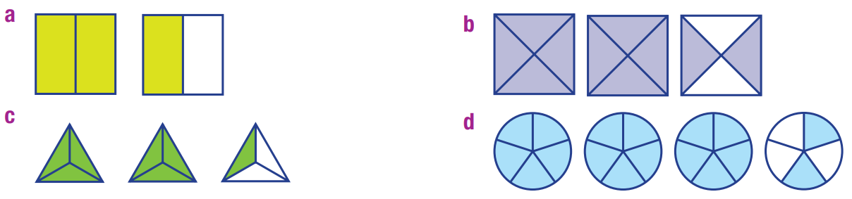  $$2\frac{2}{4}=\frac{10}{4}$$ | $$2\frac{1}{3}=\frac{7}{3}$$
$$3\frac{2}{5}=\frac{17}{5}$$ | 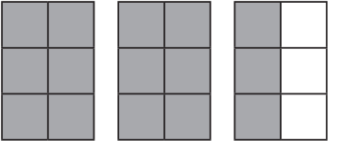  $$2\frac{3}{6}=\frac{15}{6}$$ | 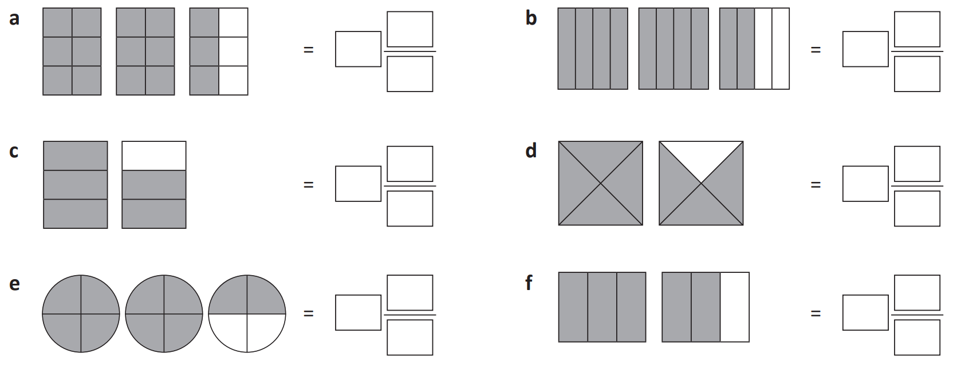  $$1\frac{2}{3}=\frac{5}{3}$$
$$1\frac{3}{4}=\frac{7}{4}$$ | $$2\frac{2}{4}=\frac{10}{4}$$ | $$1\frac{2}{3}=\frac{5}{3}$$
- Shade these shapes to represent the given fraction and fill in the boxes.
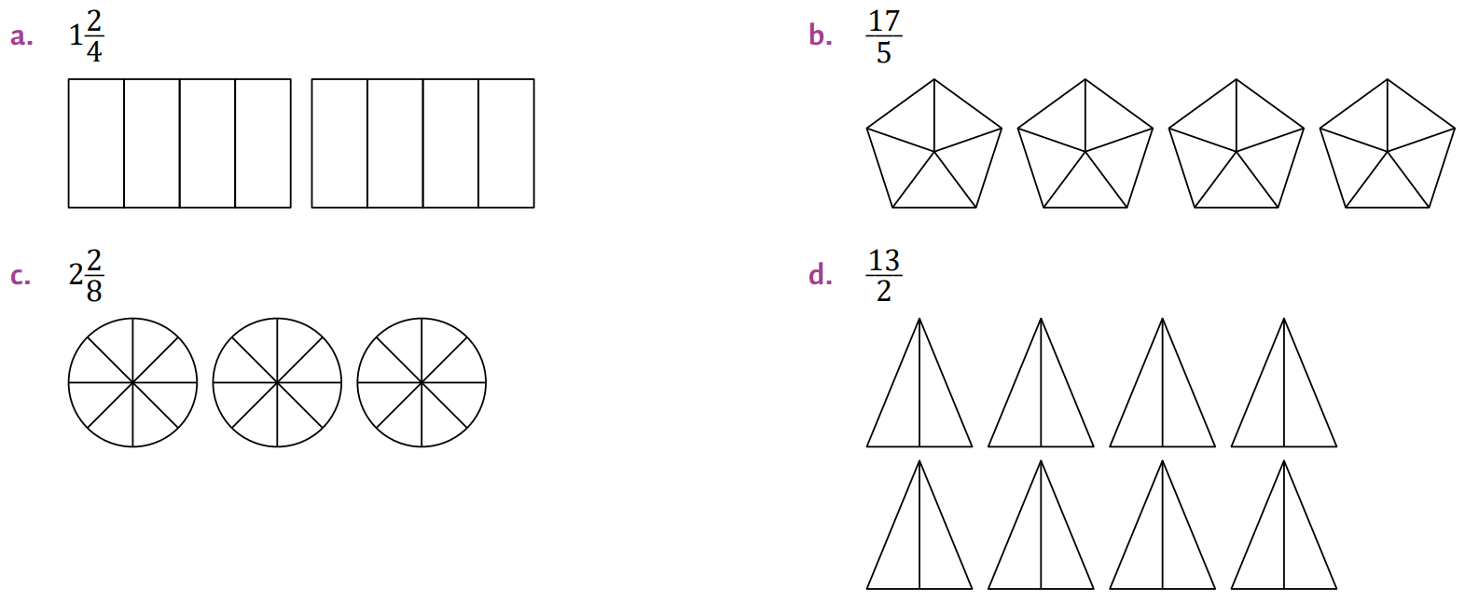  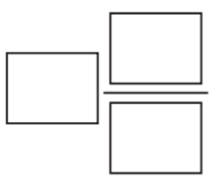  $$1\frac{2}{4}=$$  $$\frac{6}{4}$$ | $$\frac{17}{5}=$$  $$3\frac{2}{5}$$
$$2\frac{2}{8}=$$  $$\frac{18}{8}$$ | $$\frac{7}{2}=$$  $$3\frac{1}{2}$$

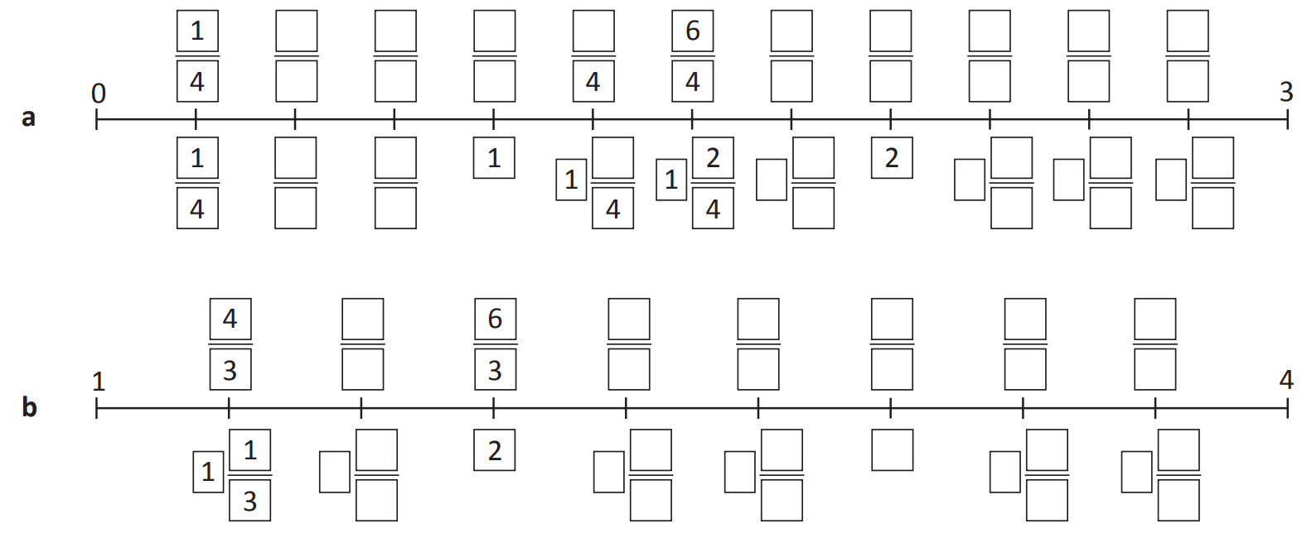
- Complete these number lines.

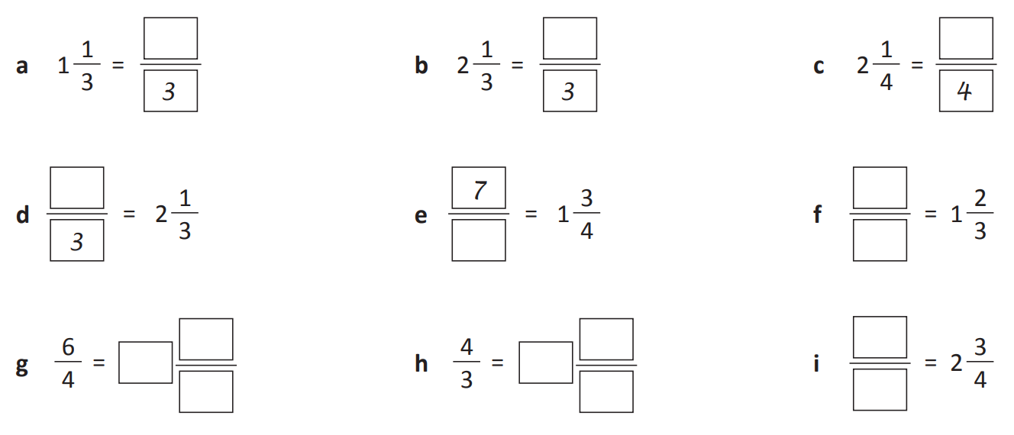
- Use the number lines above to complete these.
$$\frac{4}{3}$$ | $$\frac{7}{3}$$ | $$\frac{9}{4}$$
$$\frac{7}{3}$$ | $$\frac{7}{4}$$ | $$\frac{5}{3}$$
$$1\frac{1}{2}$$ | $$1\frac{1}{3}$$ | $$\frac{11}{4}$$

Development
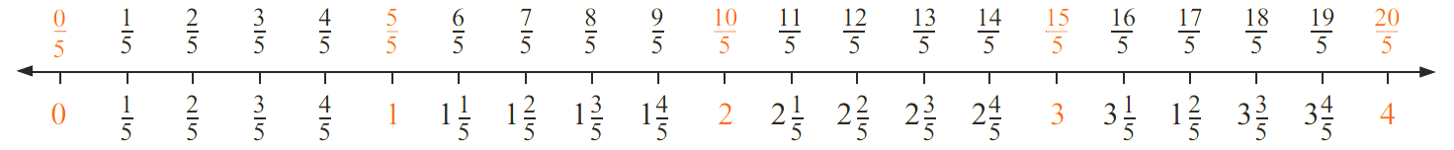
- Use the number line to answer the questions.

Write these as mixed numbers:
- $\frac{7}{5}$  $$1\frac{2}{5}$$ | - $\frac{9}{5}$  $$1\frac{4}{5}$$ | - $\frac{12}{5}$  $$2\frac{2}{5}$$ | - $\frac{19}{5}$  $$3\frac{4}{5}$$

Write these as improper fractions
- $1$ $\frac{3}{5}$  $$\frac{8}{5}$$ | - $2$ $\frac{1}{5}$  $$\frac{11}{5}$$ | - $2$ $\frac{4}{5}$  $$\frac{14}{5}$$ | - $3$ $\frac{3}{5}$  $$\frac{18}{5}$$

How many fifths are in:
- $1$ whole  5 | - $2$ wholes  10 | - $3$ wholes  15 | - $10$ wholes  50

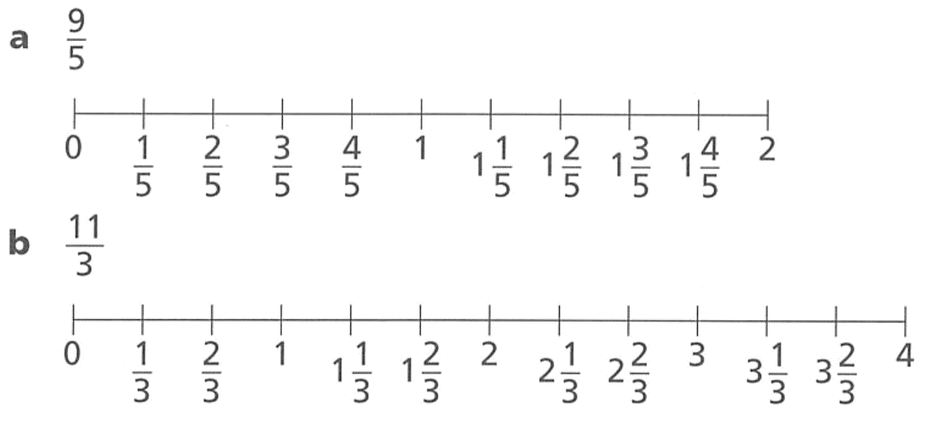
- Use the number lines to convert these improper fractions to mixed numbers.

$$1\frac{4}{5}$$

$$3\frac{2}{3}$$
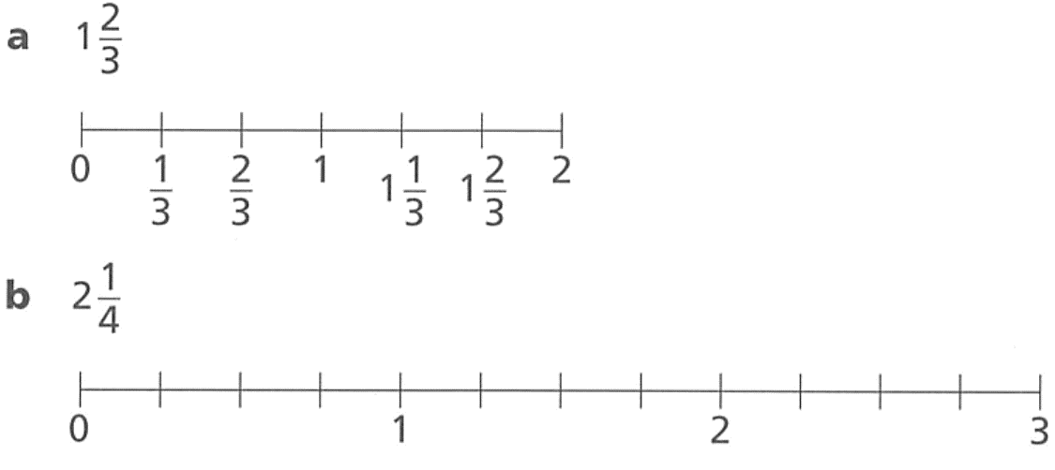
- Use the number lines to convert each mixed number to an improper fraction.

$$\frac{5}{3}$$

$$\frac{9}{4}$$
- Determine the improper fraction shown by the number line.
$$1\frac{5}{8}$$ | 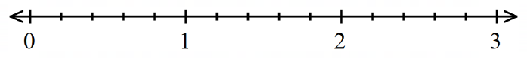  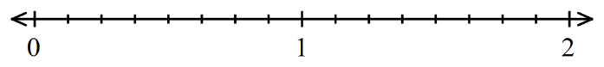  $$1\frac{3}{5}$$
$$1\frac{2}{3}$$ | 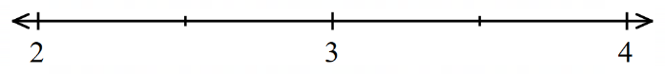  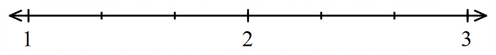  $$2\frac{1}{2}$$
$$1\frac{2}{3}$$ |  | 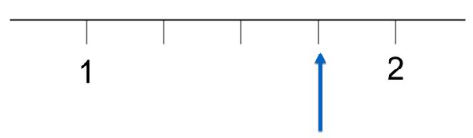  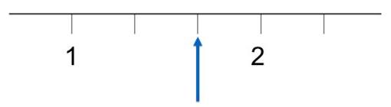  $$1\frac{3}{4}$$

- Fill in the gaps in these number patterns.
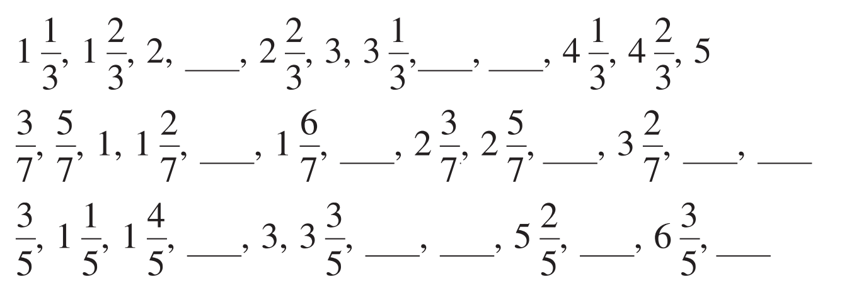

$$1\frac{4}{7}, 2\frac{1}{7}, 3, 3\frac{4}{7}, 3\frac{6}{7}$$

$$2\frac{2}{5}, 4\frac{1}{5}, 4\frac{4}{5}, 6, 7\frac{1}{5}$$

Converting Mixed Numbers and Improper Fractions

- Converting Mixed Numbers to Improper Fractions
$$whole\frac{numerator}{denominator}=\frac{\left(denominator×whole\right)+numerator}{denominator}$$
$$a\frac{b}{n}=\frac{a×n+b}{n}$$

- Example Convert mixed numbers to improper fractions
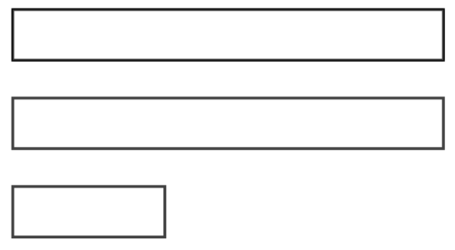
$$2\frac{1}{3}=\frac{2×3+1}{3}$$
$$=\frac{7}{3}$$

- Guided Practice
Convert these mixed numbers to improper fractions.
$$2\frac{1}{3}=\frac{ × + }{3} \\ =\frac{}{}$$ | $$4\frac{5}{6}=\frac{ × + }{6} \\ =$$ | $$3\frac{2}{7}=\frac{ }{ } \\ =$$
$$1\frac{7}{8}=$$ | $$5\frac{2}{3}=$$ | $$11\frac{1}{4}=$$

- Key Ideas
- To convert mixed numbers to improper fractions:
  - Multiply the whole by the d……………… of the fraction.
  - Add the n…………… to the result.
  - Write the sum over the original d………………… of the fraction.
- Converting Improper Fractions to Mixed Numbers
To convert improper fractions to mixed numbers:
- Divide the numerator by the denominator.
- The quotient represents the whole.
- Write the remainder over the original denominator.

- Example Convert improper fractions to mixed numbers
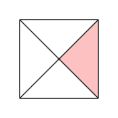
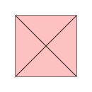
$$\frac{11}{4}=2 r3$$
$$=2\frac{3}{4}$$

- Guided Practice
Convert these improper fractions to mixed numerals.
$$\frac{7}{5}=1 rem. 2$$  $=$ | $$\frac{13}{5}=$$  $=$ | $$\frac{19}{3}=$$  $=$
$$\frac{23}{7}=$$ | $$\frac{43}{4}=$$ | $$\frac{27}{11}=$$

- Key Ideas
- To convert improper fractions to mixed numbers:
  - Divide the ………………… by the ………………….
  - The q…………… is the number of wholes.
  - Write the r……………… over the original denominator.

Foundation
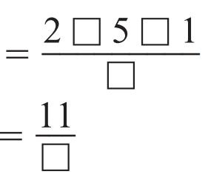
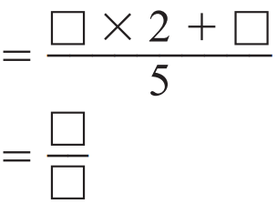
- Convert these mixed numerals to improper fractions.
- $3\frac{1}{4}$  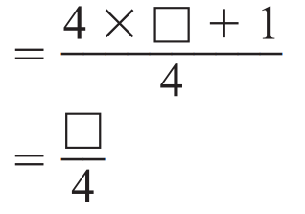  $$\frac{4×3+1}{4}=\frac{13}{4}$$ | - $2\frac{3}{5}$  $$\frac{5×2+3}{5}=\frac{13}{5}$$ | - $5\frac{1}{2}$  $$\frac{2×5+1}{2}=\frac{11}{2}$$
- $2\frac{1}{5}$  $$\frac{11}{5}$$ | - $1\frac{3}{5}$  $$\frac{8}{5}$$ | - $3\frac{1}{3}$  $$\frac{10}{3}$$
- $5\frac{2}{3}$  $$\frac{17}{3}$$ | - $4\frac{2}{7}$  $$\frac{30}{7}$$ | - $11\frac{1}{2}$  $$\frac{23}{2}$$

- Convert these improper fractions to mixed numerals.
- $\frac{7}{5}$  $7÷5=1 r2=$  $$1\frac{2}{5}$$ | - $\frac{4}{3}$  $4÷3=$ … r … $=$  $$1\frac{1}{3}$$ | - $\frac{7}{4}$  $7÷4=$ … r … $=$  $$1\frac{3}{4}$$
- $\frac{10}{4}$  $$2\frac{1}{2}$$ | - $\frac{21}{5}$  $$4\frac{1}{5}$$ | - $\frac{19}{6}$  $$3\frac{1}{6}$$
- $\frac{41}{4}$  $$10\frac{1}{4}$$ | - $\frac{81}{10}$  $$8\frac{1}{10}$$ | - $\frac{78}{7}$  $$11\frac{1}{7}$$

- Circle the improper fractions that are equivalent to integers.

$$\frac{64}{8},\frac{100}{25},\frac{49}{7},\frac{63}{9}$$

- Convert to an improper fraction.
- $1\frac{1}{5}$  $$\frac{6}{5}$$ | - $2\frac{1}{5}$  $$\frac{11}{5}$$ | - $3\frac{1}{5}$  $$\frac{16}{5}$$ | - $3\frac{2}{5}$  $$\frac{17}{5}$$
- $3\frac{3}{5}$  $$\frac{18}{5}$$ | - $3\frac{3}{10}$  $$\frac{33}{10}$$ | - $3\frac{3}{9}$  $$\frac{30}{9}$$ | - $4\frac{3}{9}$  $$\frac{39}{9}$$

- Convert to a mixed number.
- $\frac{7}{4}$  $$1\frac{3}{4}$$ | - $\frac{9}{4}$  $$2\frac{1}{4}$$ | - $\frac{9}{8}$  $$1\frac{1}{8}$$ | - $\frac{18}{8}$  $$2\frac{1}{4}$$
- $\frac{36}{8}$  $$4\frac{1}{2}$$ | - $\frac{36}{4}$  $$9$$ | - $\frac{36}{2}$  $18$ | - $\frac{37}{2}$  $$18\frac{1}{2}$$

- Complete the table.
Division | Written Calculation | Mixed Number | Improper
$$13÷5$$ | 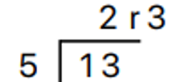 | $$2\frac{3}{5}$$ | $$\frac{13}{5}$$
$$11÷4$$ | $$2 r 3$$ | $$2\frac{3}{4}$$ | $$\frac{11}{4}$$
$$12÷7$$ | $$1 r 5$$ | $$1\frac{5}{7}$$ | $$\frac{12}{7}$$
$$18÷5$$ | 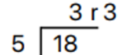 | $$3\frac{3}{5}$$ | $$\frac{18}{5}$$
$$17÷2$$ | 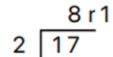 | $$8\frac{1}{2}$$ | $$\frac{17}{2}$$
$$21÷5$$ | $$4 r 1$$ | $$4\frac{1}{5}$$ | $$\frac{21}{5}$$
$$11÷3$$ | $$3 r 2$$ | $$3\frac{2}{3}$$ | $$\frac{11}{3}$$
$$22÷7$$ | $$3 r 1$$ | $$3\frac{1}{7}$$ | $$\frac{22}{7}$$
$$39÷7$$ | $$5 r 4$$ | $$5\frac{4}{7}$$ | $$\frac{39}{7}$$

Development
- Four friends order three large pizzas for their dinner. Each pizza is cut into eight equal slices. Simone has three slices, Isabella has four slices, Mark has five slices and Alex has three slices.
  - How many pizza slices do they eat in total?
15
  - How many pizzas do they eat in total as a mixed numeral?
$$1\frac{7}{8}$$
  - How many pizza slices are left uneaten?
9
  - How many pizzas are left uneaten as a mixed numeral?
$$1\frac{1}{8}$$
- Convert to a mixed number, then simplify.
- $\frac{10}{4}$  $$2\frac{1}{2}$$ | - $\frac{28}{10}$  $$2\frac{4}{5}$$ | - $\frac{16}{12}$  $$1\frac{1}{3}$$ | - $\frac{8}{6}$  $$1\frac{1}{3}$$
- $\frac{18}{16}$  $$1\frac{1}{8}$$ | - $\frac{30}{9}$  $$3\frac{1}{3}$$ | - $\frac{40}{15}$  $$2\frac{2}{3}$$ | - $\frac{60}{25}$  $$2\frac{2}{5}$$

- Use $<$, $>$, or $=$ to compare these pairs of numbers.
> | = | < | <

  - Patricia has three sandwiches that are cut into quarters, and she eats all but one-quarter.
How many quarters does she eat?
11 quarters
  - Phillip has five sandwiches that are cut into thirds, and he eats all but one-third.
How many thirds does he eat?
14 thirds
  - Crystal has $x$ sandwiches that are cut into quarters and she eats all but one-quarter.
How many quarters does she eat?
$4x-1$ quarters
  - Byron has $y$ sandwiches that are cut into thirds and he eats all but one-third.
How many thirds does he eat?
$3x-1$ thirds
  - Felicity has $m$ sandwiches that are cut into $n$pieces and she eats them all.
How many pieces does she eat?
$mn$ pieces

Mastery
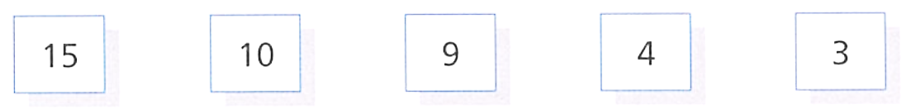
- Jakub has some number cards.

He wants to make a fraction using two of the cards.
He wants to make a number as close to 4 as he can. Which two cards should he choose?
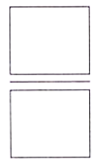
Explain your reasoning.

15 and 4.
For a fraction to be 4, the numerator must be 4 times the denominator.
15 and 4 are the closest pair possible.

- Fill in the missing number to make these equations true.
1 | 1 | 2, 9 | 7, 3
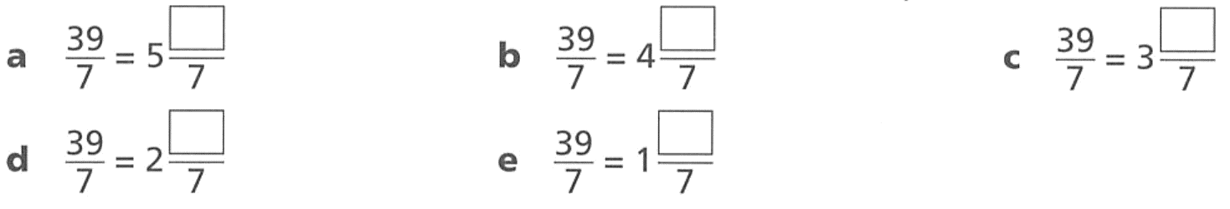  4 | 11 | 18 | 25

- Consider the number line below.
  - Show the position of 1.6
  - Show the position of $\frac{7}{10}$
  - Estimate the position of 0.75
  - If the line represents 2 m, show the position of 90 cm.

- A fully simplified mixed numeral between 2 and 3 is written as an improper fraction with a numerator of 17. List all the possible mixed numerals matching this description.

$$2\frac{5}{6}, 2\frac{3}{7}, 2\frac{1}{8}$$

Review of Common Conversions

- Common FDP Conversions
Fractions, decimals, and percentages are three different ways of representing values between whole numbers.
Memorise these common conversions between fractions, decimals, and percentages.
Fraction | Decimal | Percentage
$$1$$ | $$1$$ | $$100\%$$
$$\frac{1}{2}$$ | $$0.5$$ | $$50\%$$
$$\frac{1}{3}$$ | $$0.\dot{3}$$ | $$33.\dot{3}\%$$
$$\frac{1}{4}$$ | $$0.25$$ | $$25\%$$
$$\frac{1}{5}$$ | $$0.2$$ | $$20\%$$
$$\frac{1}{10}$$ | $$0.1$$ | $$10\%$$
$$\frac{1}{20}$$ | $$0.05$$ | $$5\%$$
$$\frac{1}{50}$$ | $$0.02$$ | $$2\%$$
$$\frac{1}{100}$$ | $$0.01$$ | $$1\%$$

Foundation
- Fill in the table.
Fraction | Decimal | Percentage
$$1$$ | $$1$$ | 100%
$$\frac{1}{2}$$ | 0.5 | 50%
$$\frac{1}{3}$$ | $$0.\dot{3}$$ | $$33.\dot{3}\%$$
$$\frac{1}{4}$$ | $$0.25$$ | 25%
$$\frac{1}{5}$$ | $$0.2$$ | 20%
$$\frac{1}{10}$$ | $$0.1$$ | 10%
$$\frac{1}{20}$$ | 0.05 | $$5\%$$
$$\frac{1}{50}$$ | 0.02 | 2%
$$\frac{1}{100}$$ | 0.01 | $$1\%$$
$$\frac{1}{10}$$ | 0.1 | 10%
$$\frac{1}{5}$$ | $$0.2$$ | 20%
$$\frac{1}{4}$$ | $$0.25$$ | $$25\%$$
$$\frac{1}{2}$$ | $$0.5$$ | 50%
$$\frac{1}{3}$$ | $$0.\dot{3}$$ | $$33.\dot{3}\%$$
$$\frac{1}{50}$$ | 0.02 | 2%
$$\frac{1}{20}$$ | 0.05 | 5%
$$\frac{1}{3}$$ | $$0.\dot{3}$$ | $$33.\dot{3}\%$$
$$\frac{1}{20}$$ | $$0.05$$ | 5%

Rational Numbers

- Rational Numbers
A rational number can be written as a ratio (or fraction):
$$\frac{a}{b}$$
$$where a and b are integers, and b≠0$$
Rational numbers include:
Fractions | Integers | Percentages | Terminating Decimals | Recurring Decimals
$$\frac{2}{3}$$ | $$2→\frac{2}{1}$$ | $$47\%→\frac{47}{100}$$ | $$0.125→\frac{125}{1000}$$ | $$0.666666…→\frac{2}{3}$$

Foundation
- Describe what is meant by a “rational” number.

A number that can be written as a fraction with integer numerator and denominator.
- Explain why all integers are rational numbers.
Every integer can be written with a denominator of 1.
Write these integers in the form $\frac{a}{b}$ where $a$ and $b$ are integers.
- $5$  $$\frac{5}{1}$$ | - $65$  $$\frac{65}{1}$$ | - $173$  $$\frac{173}{1}$$ | - $-173$  $$-\frac{173}{1}$$

- Explain why all percentages are rational numbers.
Every percentage can be written as a fraction over a power of 10.
Write these percentages in the form $\frac{a}{b}$ where $a$ and $b$ are integers.
- $60\%$  $$\frac{60}{100}=\frac{3}{5}$$ | - $1\%$  $$\frac{1}{100}$$ | - $0.5\%$  $$\frac{0.5}{100}=\frac{5}{1000}=\frac{1}{200}$$ | - $12.5\%$  $$\frac{12.5}{100}=\frac{125}{1000}=\frac{1}{8}$$

- Explain why all terminating decimals are rational numbers.
We can write terminating decimals as a fraction over a power of 10.
Write these terminating decimals in the form $\frac{a}{b}$ where $a$ and $b$ are integers.
- $0.4$  $$\frac{4}{10}=\frac{2}{5}$$ | - $0.42$  $$\frac{42}{100}=\frac{21}{50}$$ | - $0.425$  $$\frac{425}{1000}=\frac{17}{40}$$ | - $-1.0008$  $$-\frac{10008}{10000}=-1\frac{8}{10000}=-1\frac{1}{1250}$$

Converting Fractions and Decimals

- Review
- Convert decimals to fractions with denominator of power of 10
$$0.9$$ | $$0.97$$ | $$1.97$$ | $$1.973$$
$$0.03$$ | $$0.003$$ | $$0.103$$ | $$10.103$$

- Convert fractions with denominator power of 10 to decimals
$$\frac{7}{10}$$ | $$\frac{7}{100}$$ | $$\frac{7}{1000}$$ | $$\frac{37}{1000}$$
$$\frac{17}{10}$$ | $$\frac{217}{10}$$ | $$\frac{217}{100}$$ | $$\frac{217}{1000}$$

- Decimals to Fractions using Decimal Place
To convert decimals to fractions:
- Write the decimal as a fraction using place value.
  - Count the decimal places.
  - Write the number without the decimal point as the numerator.
  - Put 1 followed by the same number of zeroes as decimal places for the denominator.
- Simplify the fraction.

- Convert decimals to fractions
$$0.4=\frac{4}{10} \\ =\frac{2}{5}$$ | $$0.45=\frac{45}{100} \\ =\frac{9}{20}$$ | $$0.05=\frac{5}{100} \\ =\frac{1}{20}$$
Write these decimals as fractions, then simplify if possible.
$$0.3=\frac{ }{ }$$ | $$0.75=\frac{ }{100}=\frac{ }{ }$$ | $$0.66=\frac{ }{ }=\frac{ }{ }$$
$$0.05=$$ | $$0.002=$$ | $$0.054=$$
$$0.405=$$ | $$1.12=$$

- Fractions to Decimals using Equivalent Fractions
To convert fractions to decimals:
- Rewrite the fraction with a denominator of a power of 10: 10, 100, 1000 etc.
- Use place value to write the fraction to a decimal.
  - 10 means one decimal place, 100 means two decimal places, etc.
  - Write the numerator as the digits after the decimal point.

- Convert fractions to decimals
$$\frac{3}{5}=\frac{6}{10} \\ =0.6$$ | $$\frac{11}{20}=\frac{55}{100} \\ =0.55$$ | $$\frac{9}{30}=\frac{3}{10} \\ =0.3$$
Write these decimals as fractions, then simplify if possible.
- $\frac{7}{10}$ $=$ | - $\frac{3}{100}$ $=$ | - $\frac{4}{20}$ $=$ $\frac{ }{10}$
- $\frac{22}{50}$ $=$ | - $\frac{3}{25}$ $=$ | - $\frac{21}{30}=$
- $\frac{12}{20}$ $=$ | - $\frac{16}{40}$ $=$ | - $\frac{18}{75}=$

Foundation
- Write the missing numbers.
30 | 3 | 100

- Write the missing numbers.
7 | 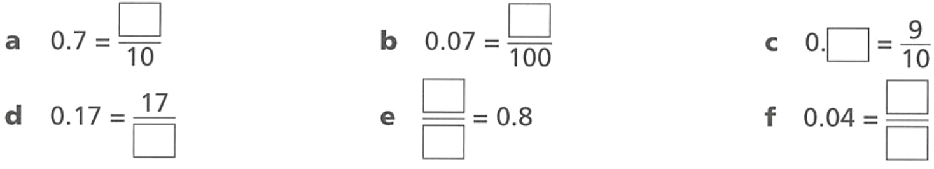  7 | 9
100 | $$\frac{8}{10}$$ | $$\frac{4}{100}=\frac{1}{25}$$

- Write the missing numbers.
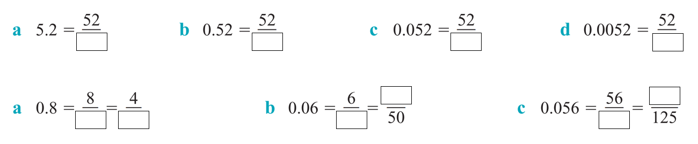  10 | 100 |  | 1000 |  | 10000
10, 5 |  | 100, 3 |  | 1000, 7

- Write the missing numbers, then write as a decimal.
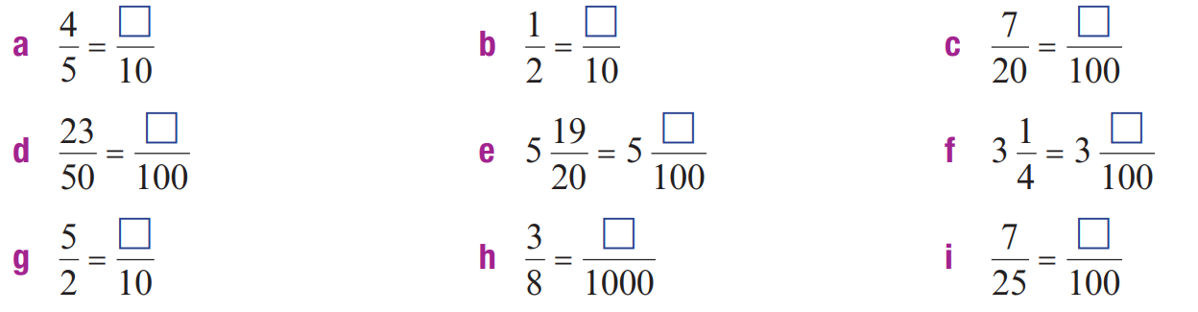  = …………  $$8$$ | = …………  $$5$$ | = …………  $$35$$
= …………  $$46$$ | = …………  $$95$$ | = …………  $$25$$
= …………  $$25$$ | = …………  $$375$$ | = …………  $$28$$

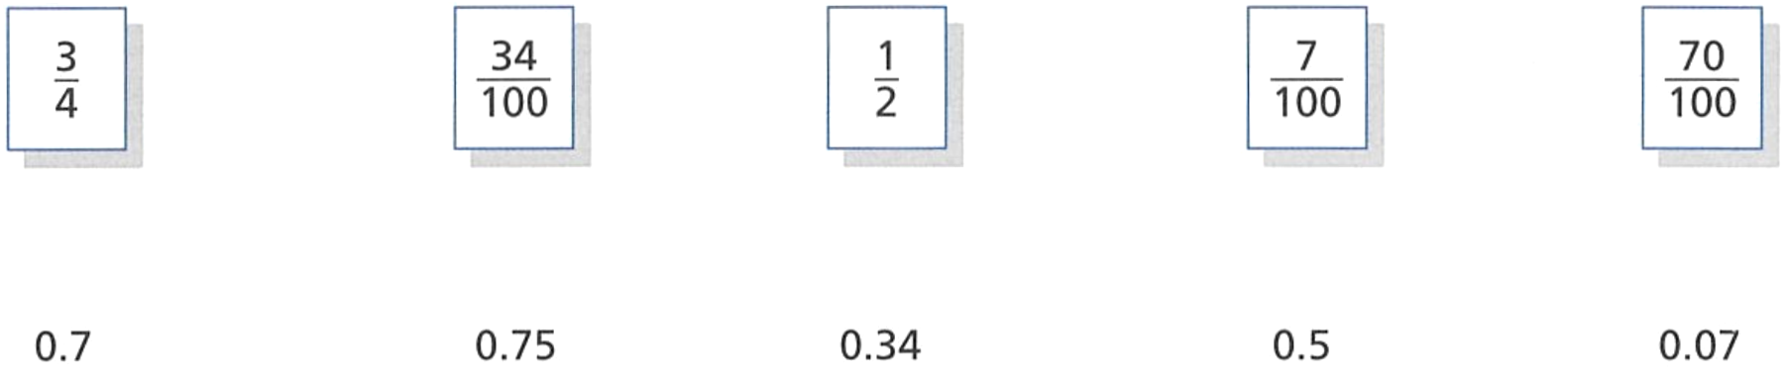
- Match the equivalent decimals and fractions.

$$\frac{3}{4}=0.75, \frac{34}{100}=0.34, \frac{1}{2}=0.5, \frac{7}{100}=0.07, \frac{70}{100}=7$$
- Write each of these fractions as a decimal.
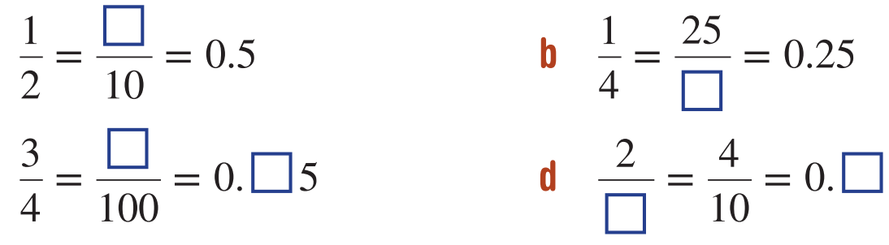  $$5$$ | $$100$$ | $$75, 7$$
$$5, 4$$ | $$2$$ | $$15, 20$$
$$10, 4$$ | $$16$$

- Write these fraction sums as decimals using your knowledge of place value.
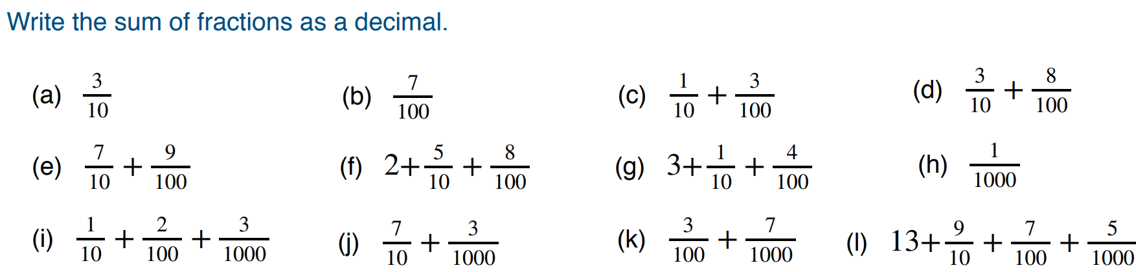  0.3 | 0.07 | 0.13
0.38 | 0.79 | 2.58
3.14 | 0.001 | 0.123
0.703 | 0.037 | 13.975

- Using a calculator, express the following fractions as recurring decimals.
$$\frac{1}{3}$$  $$0.\dot{3}$$ | $$\frac{5}{9}$$  $$0.\dot{5}$$ | $$\frac{5}{6}$$  $$0.8\dot{3}$$ | $$\frac{8}{11}$$  $$0.\overline{72}$$
$$\frac{3}{7}$$  $$0.\overline{428571}$$ | $$\frac{5}{13}$$  $$0.\overline{384615}$$ | $$3\frac{2}{15}$$  $$3.1\dot{3}$$ | $$4\frac{6}{7}$$  $$4.\overline{857142}$$

Development
- Convert these decimals to fractions in their simplest form. Do not answer as mixed numerals.
- 0.5  $$\frac{1}{2}$$ | - 6.4  $$\frac{32}{5}$$ | - 10.15  $$\frac{203}{20}$$ | - 18.12  $$\frac{453}{25}$$
- 3.25  $$\frac{13}{4}$$ | - 0.05  $$\frac{1}{20}$$ | - 9.075  $$\frac{363}{40}$$ | - 5.192  $$\frac{649}{125}$$

- Convert these fractions to decimals.
- $\frac{7}{10}$  0.7 | - $\frac{9}{10}$  0.9 | - $\frac{31}{100}$  0.31 | - $\frac{79}{100}$  0.79
- $\frac{121}{100}$  1.21 | - $\frac{329}{100}$  3.29 | - $\frac{123}{1000}$  0.123 | - $\frac{3}{100}$  0.03

- Convert these fractions to decimals by first changing them to an equivalent fraction with a denominator of 10, 100, or 1000.
- $\frac{4}{5}$  0.8 | - $\frac{1}{2}$  0.5 | - $\frac{7}{20}$  0.35 | - $\frac{23}{50}$  0.46
- $\frac{5}{2}$  2.5 | - $\frac{39}{20}$  1.95 | - $\frac{7}{4}$  1.75 | - $\frac{21}{300}$  0.07

- Complete the fraction to decimal table.
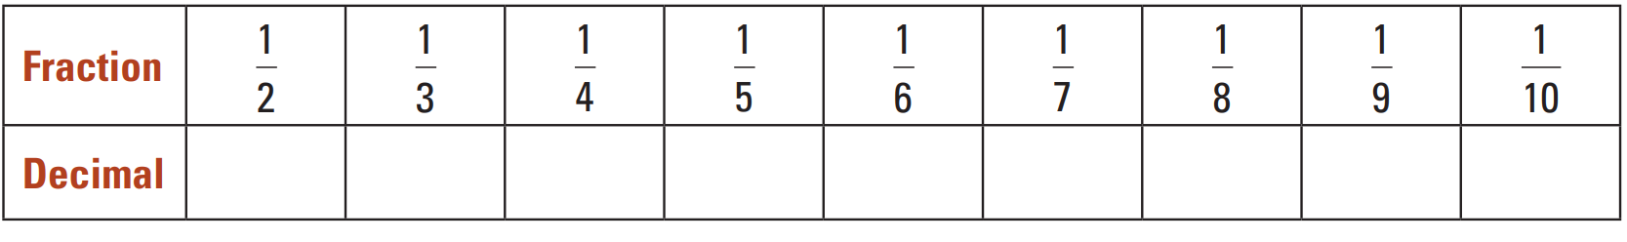

  - Describe what happens to the value of the decimal as the denominator increases.
The decimal value decreases.
  - Explain why this happens.
A larger denominator means the whole is split into more equal parts. More equal parts means each part is smaller.

Terminating and Recurring Decimals as Fractions

- Recurring Decimals as Fractions
Every terminating decimal can be written as a fraction using knowledge of place value:
$$0.827=827 thousandths \\ =\frac{827}{1000}$$
Every recurring decimal can also be written as a fraction by looking at patterns.
You will learn a formal proof after learning algebraic equations.
$$0.\dot{3}→\frac{1}{3}$$

Foundation
- $\frac{1}{3}$ as a decimal is 0.333333333333333…
  - Express this recurring decimal using the correct notation.
$$0.\dot{3}$$
  - Without using a calculator, what would $\frac{2}{3}$ be?
$$0.\dot{6}$$
  - Check $2÷3$ on a calculator. Explain why it is different to your answer to part b.

The calculator ran out of digits in its display, so it rounded the last digit up to 7.
- Convert to a decimal:
- $\frac{1}{3}=0.3333333333333333…=0.\dot{3}$ | - $\frac{1}{7}=$  $$0.\overline{142857}$$
- $\frac{2}{3}=$  $$0.\dot{6}$$ | - $\frac{2}{7}=$  $$0.\overline{285714}$$
- $\frac{2}{6}=$  $$0.\dot{3}$$ | - $\frac{3}{7}=$  $$0.\overline{428571}$$
- $\frac{3}{6}=$  $$0.5$$ | - $\frac{4}{7}=$  $$0.\overline{571428}$$
- $\frac{4}{6}=$  $$0.\dot{6}$$ | - $\frac{5}{7}=$  $$0.\overline{714285}$$
- $\frac{6}{6}=$  1 | - $\frac{6}{7}=$  $$0.\overline{857142}$$
- $\frac{7}{6}=$
$$1.1\dot{6}$$

Development
- Using a calculator, convert these to decimals.
- $\frac{1}{9}$  $$0.\dot{1}$$ | - $\frac{2}{9}$  $$0.\dot{2}$$ | - $\frac{3}{9}$  $$0.\dot{3}$$
- $\frac{4}{9}$  $$0.\dot{4}$$ | - $\frac{7}{9}$  $$0.\dot{7}$$ | - $\frac{8}{9}$  $$0.\dot{8}$$

Using the pattern above, express these as fractions:
- $0.\dot{4}$  $$\frac{4}{9}$$ | - $0.\dot{8}$  $$\frac{8}{9}$$ | - $0.\dot{6}$  $$\frac{6}{9}=\frac{2}{3}$$

- Using a calculator, convert these to decimals.
- $\frac{1}{99}$  $$0.\overline{01}$$ | - $\frac{8}{99}$  $$0.\overline{08}$$ | - $\frac{14}{99}$  $$0.\overline{14}$$
- $\frac{48}{99}$  $$0.\overline{48}$$ | - $\frac{72}{99}$  $$0.\overline{72}$$ | - $\frac{87}{99}$  $$0.\overline{87}$$

Using the pattern above, express these as fractions:
- $0.\overline{64}$  $$\frac{64}{99}$$ | - $0.\overline{05}$  $$\frac{5}{99}$$ | - $0.\overline{93}$  $$\frac{93}{99}=\frac{31}{33}$$

- Using a calculator, convert these to decimals.
- $\frac{1}{999}$  $$0.\overline{001}$$ | - $\frac{12}{999}$  $$0.\overline{012}$$ | - $\frac{412}{999}$  $$0.\overline{412}$$

Using the pattern above, express these as fractions:
- $0.\overline{942}$  $$\frac{942}{999}=\frac{314}{333}$$ | - $0.\overline{023}$  $$\frac{23}{999}$$ | - $0.\overline{138}$  $$\frac{138}{999}$$

Mastery
- Convert these decimals to fractions.
- $0.\dot{3}$  $$\frac{1}{3}$$ | - $0.1\dot{4}$  $$\frac{1}{10}+\frac{4}{90}=\frac{13}{90}$$ | - $1.0\overline{14}$  $$1\frac{144}{990}=1\frac{7}{445}$$
- $0.\overline{34}$  $$\frac{34}{99}$$ | - $0.01\dot{4}$  $$\frac{1}{100}+\frac{4}{900}=\frac{13}{900}$$ | - $2.\dot{4}$  $$2\frac{4}{9}$$
- $0.\overline{35}$  $$\frac{35}{99}$$ | - $0.\overline{014}$  $$\frac{14}{999}$$ | - $2.\overline{43}$  $$2\frac{43}{9}$$
- $0.\overline{357}$  $$\frac{357}{999}$$ | - $1.\dot{4}$  $$1\frac{4}{9}$$ | - $3.\overline{43}$  $$3\frac{43}{99}$$
- $0.\dot{4}$  $$\frac{4}{9}$$ | - $1.0\dot{4}$  $$1\frac{13}{90}$$ | - $3.0\overline{43}$  $$3\frac{43}{990}$$
- $0.0\dot{4}$  $$\frac{4}{90}=\frac{2}{45}$$ | - $1.\overline{14}$  $$1\frac{14}{99}$$

- Every recurring decimal is a rational number. Do you agree with this statement?

Yes.

Percentages to Fractions and Decimals

- Converting Percentages to Fractions
To convert a percentage to a fraction:
- Write the percentage as a fraction with denominator 100.
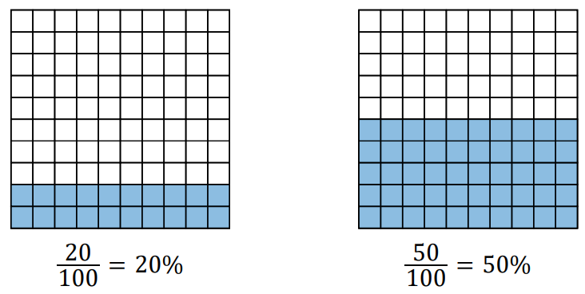
- Simplify the fraction.

$$n\%=\frac{n}{100}$$

- Convert percentages to fractions
$$6\%=\frac{6}{100} \\ =\frac{3}{50}$$ | $$120\%=\frac{120}{100} \\ =\frac{6}{5}$$ | $$10.5\%=\frac{10.5}{100} \\ =\frac{21}{200}$$
Write these percentages as fractions, then simplify if possible.
- $8\%=$ $\frac{ }{100}$  $=$ | - $10\%=$  $=$ | - $88\%$
- $66\%$ | - $600\%$ | - $125\%$
- $17.5\%$ | - $0.2\%$ | - $0.05\%$

- Converting Percentages to Decimals
To convert a percentage to a decimal:
- Divide by 100.
This is the same as moving the decimal 2 places to the left.

$$n\%=n÷100$$

- Convert percentages to decimals
$$82\%=0.82$$ | $$80\%=0.8$$ | $$8\%=0.08$$
Write these percentages as decimals, then simplify if possible.
- $82\%=$ $82÷100$  $=$ | - $8\%=$  $=$ | - $60\%$
- $8\%$ | - $35\%$ | - $12.5\%$
- $180\%$ | - $275\%$ | - $0.8\%$
- $21.5\%$ | - $17.02\%$ | - $0.25\%$

- Key Ideas
- Percent means “out of ……………”
- To convert percentages to fractions, write the number over …………… and simplify.
- To convert percentages to decimals, divide by …………

Foundation
- Express these percentages as fractions out of 100, then simplify if possible.
 | 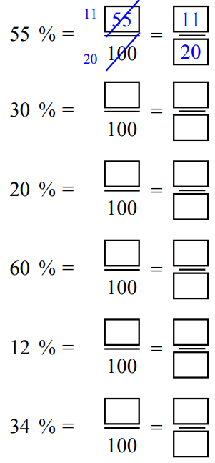  $$\frac{3}{10}$$ | $$\frac{1}{5}$$
$$\frac{3}{25}$$ | $$\frac{17}{50}$$ | 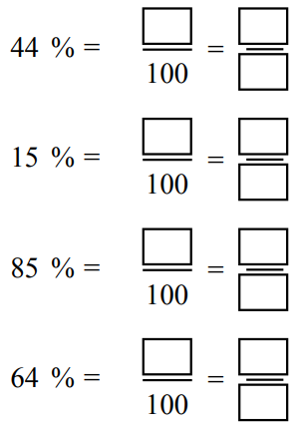  $$\frac{11}{25}$$
$$\frac{3}{20}$$ | $$\frac{17}{20}$$ | $$\frac{16}{25}$$
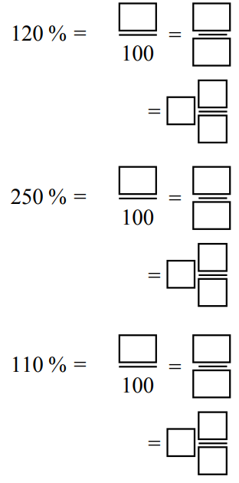  $$1\frac{1}{5}$$ | $$2\frac{1}{2}$$ | $$1\frac{1}{10}$$
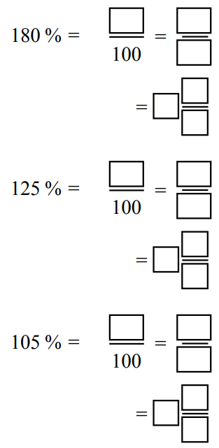  $$1\frac{4}{5}$$ | $$1\frac{1}{4}$$ | $$1\frac{1}{20}$$

- Express these fractions as fractions out of 100, then as percentages.
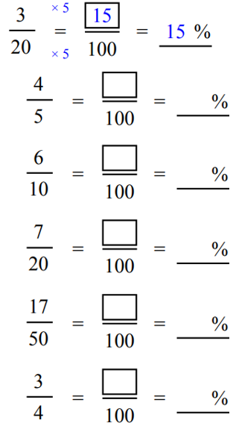 | 80% | 60%
35% | 34% | 75%
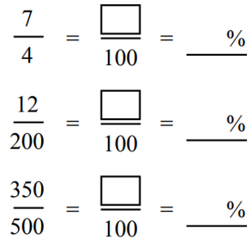  175% | 6% | 70%
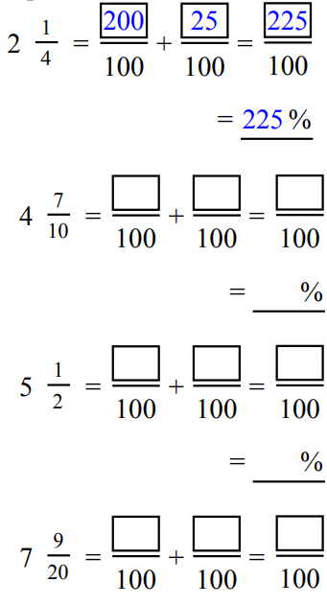 | 470% | 550%

Development
- Use your knowledge of factors of 100 to write these fractions as decimals.
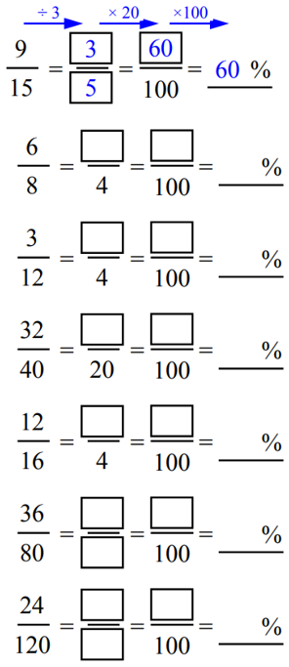 | 75% | 25%
80% | 45% | 20%
65% | 75% | 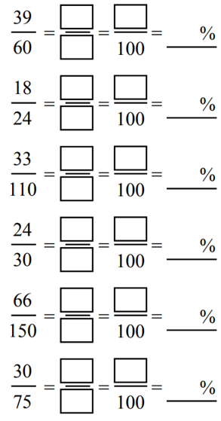  30%
80% | 44% | 40%

- Express these percentages as decimals and fractions in their simplest form.
- $25\%$  $$=\frac{25}{100}=\frac{1}{4}$$  $$=0.25$$ | - 12%  $$0.12,\frac{3}{25}$$ | - 6%  $$0.06,\frac{3}{50}$$ | - 15%  $$0.15,\frac{3}{20}$$
- 88%  $$0.88,\frac{22}{25}$$ | - 60%  $$0.6,\frac{3}{5}$$ | - 120%  $$1.2,\frac{6}{5}$$ | - 840%  $$8.4,\frac{42}{5}$$
- 76%  $$0.76,\frac{19}{25}$$ | - 42%  $$0.42,\frac{21}{50}$$ | - 45%  $$0.45,\frac{9}{20}$$ | - 7%  $$0.07,\frac{7}{100}$$

- Convert these fractions to percentages, using equivalent fractions.
- $\frac{8}{25}$  $$=\frac{}{100}$$  $$=32\%$$ | - $\frac{8}{10}$  80% | - $\frac{6}{50}$  12% | - $\frac{7}{20}$  35%
- $\frac{43}{50}$  86% | - $\frac{18}{20}$  90% | - $\frac{15}{25}$  60% | - $\frac{3}{5}$  60%
- $\frac{3}{4}$  75% | - $\frac{7}{4}$  175% | - $\frac{68}{50}$  136% | - $\frac{5}{2}$  250%
- $\frac{24}{40}$  60% | - $\frac{9}{30}$  30% | - $\frac{21}{15}$  140% | - $\frac{51}{60}$  85%

  - If 14% of students in Year 7 are absent due to illness, what percentage of Year 7 students are at school?

86%
  - If 80% of the population is vaccinated, what percentage has not been vaccinated?

20%

- Rachel’s birthday cake is cut into eight equal pieces. Rachel eats six pieces.
  - What percentage did Rachel eat?

75%
  - What percentage of the cake remains?

25%

Mastery
- Change these test results to equivalent scores out of 100, and therefore state the percentage.
- 7 out of 10  = ……… out of 100  = ……… %  70% | - 24 out of 50  = ……… out of 100  = ……… %  48% | - 12 out of 20  = ……… out of 100  = ……… %  60%
- 1 out of 5  20% | - 80 out of 200  40% | - 630 out of 1000  63%

- Michael achieved a score of 68% in a test. If the test was out of 50, what was his mark?

$$\frac{68}{100}=\frac{34}{50}$$
34
- Karla received 16 out of 20 marks in her test. What was her mark as a percentage?

80%
- Brian drinks 580 mL out of a 2 litre jug of milk. How much milk is left, as a percentage?

$$71\%$$
- Geordy scores 28 out of 30 on his fractions test. What is his percentage score?

$93.\dot{3}$%
- Gillian pays $80 tax out of her income of $1600.
What percentage of her income does she keep?

95%
- Over summer, a dam’s water volume reduces from 20 megalitres to 4 megalitres.
What fraction of the water in the dam has been lost?

80%
- For a recent class test, Ross scored 45 out of 60 and Marsha scored 72 out of 100.
Use percentages to show that Ross obtained the higher mark.

Ross: 75%
Marsha: 72%
- A new apartment has 300 apartments. 40% have been sold. How many apartments is this? (hint: make an equivalent fraction with 300 as the denominator)

$$\frac{40}{100}=\frac{120}{300}$$
120 apartments
- Ian gets up during the night 8% of time. How many times would he get up in 25 nights?

$$\frac{8}{100}=\frac{2}{25}$$
2 times
- Jane scored 12 out of 20 in her previous test.
If the next test is out of 50, what must she score for the same percentage?

$$\frac{12}{20}=\frac{6}{10}=\frac{30}{50}$$

Summary of FDP Conversions

- FDP Conversions
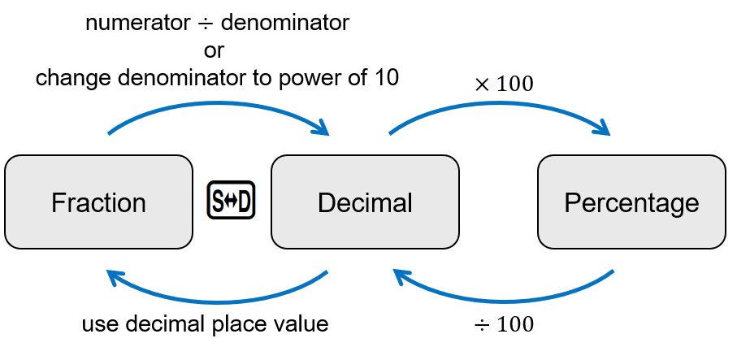

Foundation
- Complete these conversions.
  Fraction | Decimal
  $$\frac{1}{5}$$ | 0.2
  $$\frac{2}{5}$$ | 0.4
  $$\frac{3}{5}$$ | 0.6
  $$\frac{30}{50}$$ | 0.6
  $$\frac{3}{500}$$ | 0.006
  $$\frac{5}{3}$$ | $1.\dot{6}$
  $$\frac{1}{6}$$ | $0.1\dot{6}$
  $$\frac{2}{6}$$ | $$0.\dot{3}$$
  $$\frac{2}{60}$$ | $$0.0\dot{3}$$
  $$\frac{2}{600}$$ | $$0.00\dot{3}$$
  $$\frac{20}{60}$$ | $$0.\dot{3}$$
  $$\frac{3}{60}$$ | $$0.05$$
  $$\frac{6}{30}$$ | 0.2
  Decimal | Fraction
  0.6 | $$\frac{3}{5}$$
  0.06 | $$\frac{3}{50}$$
  0.66 | $$\frac{33}{50}$$
  0.65 | $$\frac{13}{20}$$
  0.56 | $$\frac{23}{50}$$
  0.55 | $$\frac{11}{20}$$
  0.006 | $$\frac{3}{500}$$
  0.055 | $$\frac{11}{200}$$
  0.065 | $$\frac{13}{200}$$
  0.605 | $$\frac{121}{200}$$
  6.5 | $$\frac{13}{2}$$
  6.05 | $$\frac{121}{20}$$
  6.005 | $$\frac{1201}{200}$$
  Percent | Decimal
  32% | 0.32
  31% | 0.31
  30% | 0.3
  3% | 0.03
  0.3% | 0.003
  1.3% | 0.013
  1.23% | 0.0123
  12.3% | 0.123
  123% | 1.23
  1023% | 10.23
  1003% | 10.03
  103% | 1.03
  130% | 1.3
  129% | 1.29
  12.9% | 0.129
  12.92% | 0.1292
  Decimal | Percent
  0.48 | 48%
  0.49 | 49%
  0.50 | 50%
  0.5 | 50%
  0.05 | 5%
  0.005 | 0.5%
  0.085 | 8.5%
  0.85 | 85%
  1.85 | 185%
  1.085 | 108.5%
  2.085 | 208.5%
  2.58 | 258%
  2.5 | 250%
  2 | 200%
  0.2 | 20%
  0.25 | 25%

- Complete these conversion tables.
  Fraction | Decimal | Percentage
  $$\frac{1}{5}$$ | 0.2 | 20%
  $$\frac{2}{5}$$ | 0.4 | 40%
  $$\frac{6}{5}$$ | 1.2 | 120%
  $$2\frac{3}{5}$$ | 2.6 | 260%
  Fraction | Decimal | Percentage
  $$\frac{1}{4}$$ | 0.25 | 25%
  $$\frac{3}{4}$$ | 0.75 | 75%
  $$\frac{6}{4}$$ | 1.5 | 150%
  $$\frac{5}{4}$$ | 1.25 | 125%
  Fraction | Decimal | Percentage
  $$\frac{1}{10}$$ | 0.1 | 10%
  $$\frac{1}{100}$$ | 0.01 | 1%
  $$\frac{1}{25}$$ | 0.04 | 4%
  $$\frac{3}{25}$$ | 0.12 | 12%
  Fraction | Decimal | Percentage
  $$\frac{1}{3}$$ | $$0.\dot{3}$$ | $$33.\dot{3}\%$$
  $$\frac{2}{3}$$ | $$0.\dot{6}$$ | $$66.\dot{6}\%$$
  $$\frac{3}{3}=1$$ | $$0.\dot{9}=1$$ | $$99.\dot{9}\%$$
  $$1\frac{2}{3}$$ | $$1.\dot{6}$$ | $$166.\dot{6}\%$$
  Fraction | Decimal | Percentage
  $$\frac{1}{20}$$ | 0.05 | 5%
  $$\frac{1}{40}$$ | 0.025 | 2.5%
  $$\frac{7}{40}$$ | 0.175 | 17.5%
  $$\frac{3}{40}$$ | 0.075 | 7.5%
  Fraction | Decimal | Percentage
  $$\frac{1}{50}$$ | 0.02 | 2%
  $$\frac{23}{50}$$ | 0.46 | 46%
  $$\frac{43}{50}$$ | 0.86 | 86%
  $$2\frac{7}{50}$$ | $$2.14$$ | $$214\%$$

Fraction | Decimal | Percentage
$$\frac{1}{10}$$
 | 0.2
 |  | 25%
$$\frac{1}{2}$$
 |  | 40%
 | 0.6
 | 0.7
 | 0.75
$$\frac{4}{5}$$
 |  | 90%
$$\frac{1}{100}$$
 | 0.05
 |  | 45%
$$\frac{7}{20}$$
 | 0.12

- For each grid, write down the proportion of the total area that is shaded as:
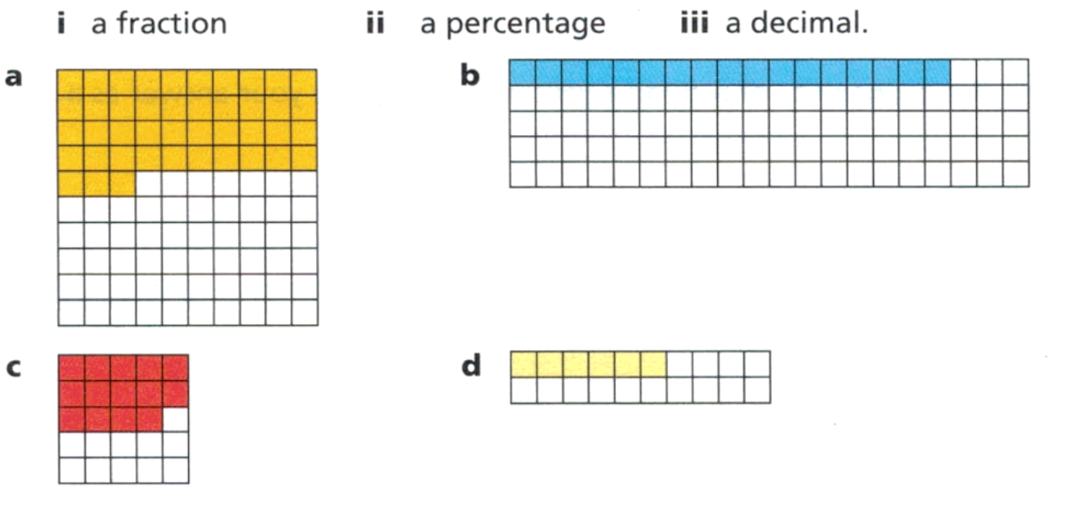

Fraction  $$\frac{43}{100}$$  Decimal  0.43  Percentage  43% | Fraction  $$\frac{17}{100}$$  Decimal  0.17  Percentage  17% | Fraction  $$\frac{14}{25}$$  Decimal  $$0.56$$  Percentage  56%

- Write each shaded area as a fraction, decimal, and percentage of the total area.
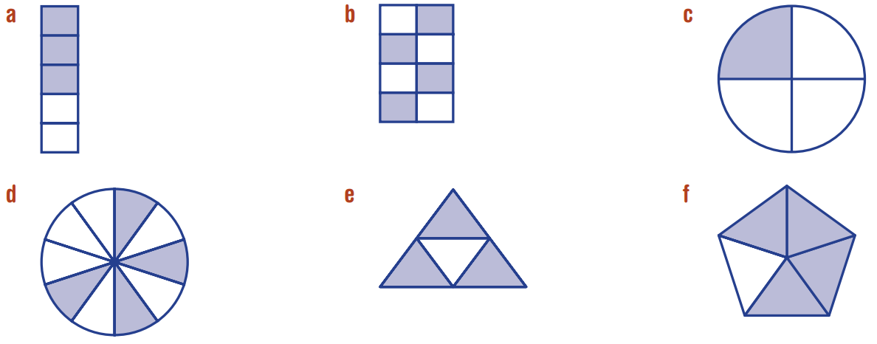  Fraction  $$\frac{3}{5}$$  Decimal  0.6  Percentage  60% | Fraction  $$\frac{1}{2}$$  Decimal  0.5  Percentage  $$50\%$$ | Fraction  $$\frac{1}{4}$$  Decimal  $$0.25$$  Percentage  25%
Fraction  $$\frac{4}{10}$$  Decimal  0.4  Percentage  40% | Fraction  $$\frac{3}{4}$$  Decimal  0.75  Percentage  75% | Fraction  $$\frac{4}{5}$$  Decimal  0.8  Percentage  80%

- Complete the following, writing <, > or = in the circles to make each statement correct.

= > < =

Development
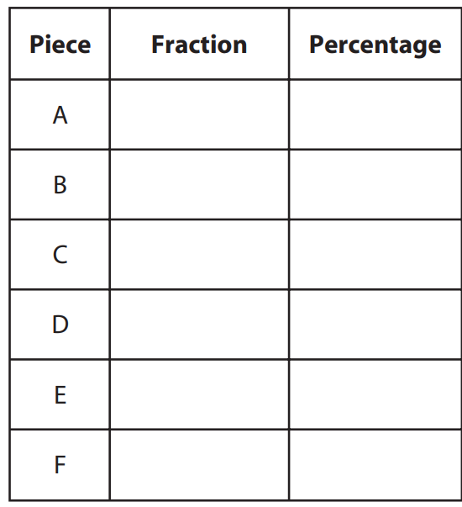
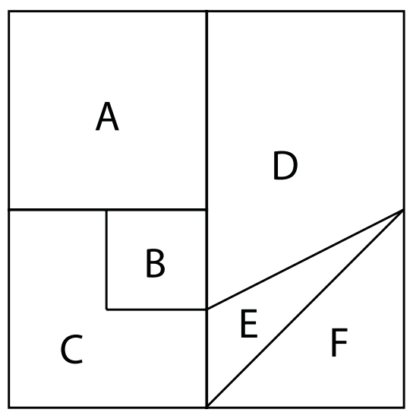
- A square has been dissected into 6 pieces. Express each piece as a fraction and percentage of the whole. Check that your pieces sum to 1.

25%
6.25%
18.75%
31.25%
6.25%
12.5%

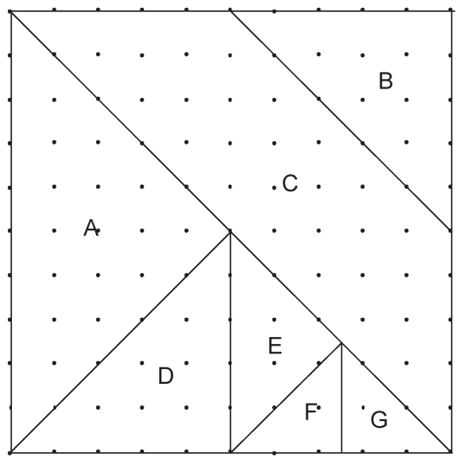
25%
12.5%
37.5%
12.5%
6.25%
3.125%
3.125%

- Write three different fractions with different denominators that are between 2.4 and 2.5.
The two fractions are:
$$\frac{24}{10} and\frac{25}{10}$$
$$=\frac{48}{20} and \frac{50}{20}$$
One fraction in between could be $\frac{49}{20}$
Also consider
$$\frac{240}{100} and\frac{250}{100}$$
Another fraction in between is $\frac{249}{100}$
Many other answers are possible.

Irrational Numbers

- Rational vs Irrational
Rational numbers can be written as a fraction $\frac{a}{b}$ where $a$ and $b$ are integers and $b≠0$. | Irrational numbers cannot be written as a fraction, such as $π$ and $\sqrt{2}$.  As decimals, they are non-terminating and non-recurring.
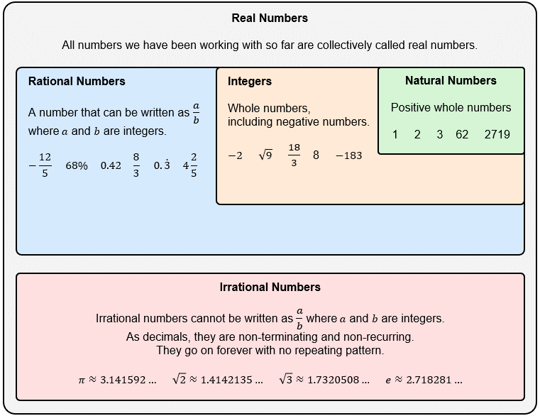

- Identify whether a number is rational or irrational
Using a calculator, represent these numbers as decimals and decide whether they are irrational or rational.
- $\frac{1}{3}$ Rational Irrational | - $\sqrt{4}$ Rational Irrational
- $3$ Rational Irrational | - $\sqrt{5}$ Rational Irrational
- $0.3$ Rational Irrational | - $\sqrt{5}+1$ Rational Irrational
- $0.\dot{3}$ Rational Irrational | - $\frac{\sqrt{2}}{2}$ Rational Irrational
- $\sqrt{3}$ Rational Irrational | - $2\sqrt{2}$ Rational Irrational
- $\sqrt{9}$ Rational Irrational | - $π$ Rational Irrational
- $0.25$ Rational Irrational | - $-\frac{22.5}{7}$ Rational Irrational
- $25\%$ Rational Irrational | - $3.\overline{14}$ Rational Irrational

- Key Ideas
- Rational numbers can be written as a fraction $\frac{a}{b}$, where $a$ and $b$ are ………………… and $b≠0$
- If a number can be written as a terminating or ……………… decimal, then it is rational.
- Irrational numbers cannot be written as a fraction with integers, when written as a decimal, they are non-…………………………… and non-……………………………

- Example Approximate irrational numbers
Approximate $\sqrt{2}$ to 2 decimal places.  $\sqrt{2}=1.414213562…$  $≈1.41$ | Approximate $e$ to 2 decimal places.  $e=2.718281828…$  $≈2.72$

- Guided Practice
Approximate these numbers to 2 decimal places.
- $\sqrt{3}$  1.73 | - $π$  3.14 | - $\sqrt{25}$  5.00
- $\sqrt{18}$  4.24 | - $\frac{1}{\sqrt{3}}$  0.58 | - $2\sqrt{2}$  2.83

- Example Locate the approximate location of irrational numbers
$\sqrt{2}≈1.41$  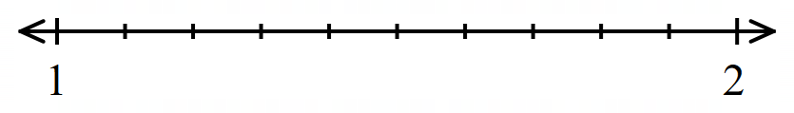 | $e≈2.72$  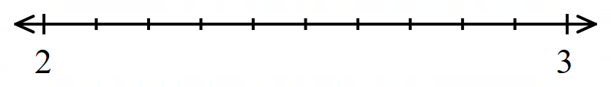

- Guided Practice
Using a calculator, locate the approximate location of these numbers on the number line.
- $\sqrt{3}$
- $-\sqrt{5}$
- $\frac{\sqrt{2}}{2}$
- $-π$

Foundation
- Circle which of these numbers are integers.
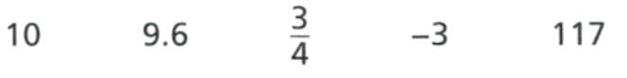
10, $-3$, 117
Explain why all integers are rational numbers.

Integers can be written with a denominator of 1.
- Circle which of these numbers are rational.
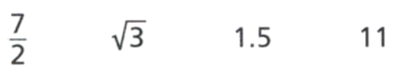

$$\frac{7}{2}, 1.5, 11$$
Explain how you know whether a number is rational.

The number can be written as a fraction with whole number numerator and denominator.
- Explain why $\sqrt{4}$ is a rational number.

$\sqrt{4}=2$, which is an integer, so it’s rational.
- Look at these numbers.

  - Which numbers are irrational?
$$\sqrt{3}, \sqrt{5}, 3\sqrt{7}, -\sqrt{3}$$
  - Which numbers are rational?
$$\sqrt{4}, 2\sqrt{100}, -\sqrt{25}$$

- Emily says:

0.7777... recurring is irrational as you cannot write it as a fraction.

Explain why she is incorrect.

0.777… can be written as $\frac{7}{9}$, so it’s rational.


- Dolly says:
$π$ is a rational number, since it is roughly equal to $\frac{22}{7}$

Explain why Dolly is incorrect.

$π$ is roughly equal to $\frac{22}{7}$ but not exactly. $π$ is a non-terminating, non-recurring decimal, so it is irrational.

- Becky says:
$\sqrt{25}$ is not rational, because it is a square root.

Explain why Becky is incorrect.

$\sqrt{25}$ simplifies to 5, which is rational.
- Using a calculator, approximate these numbers to 2 decimal places.
- $\sqrt{5}$  2.24 | - $2\sqrt{5}$  4.47 | - 1.61803399  1.62
- $\frac{22}{7}$  3.14 | - $\frac{π}{2}$  1.57 | - $e^{2}$  7.39

Development
- Complete the table.
Number | Rational/ Irrational? | Approximation  (2 d.p.) | Approximation  (3 d.p.) | Approximate location on number line
$$e$$ | Irrational | $$≈2.72$$ | $$≈2.718$$ | 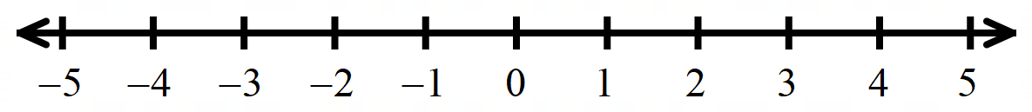
$$\sqrt{6}$$ | Irrational | 2.45 | 2.449
$$2\sqrt{6}$$ | Irrational | 4.90 | 4.899
$$\sqrt{24}$$ | Irrational | 4.90 | 4.899
$$\sqrt{13}$$ | Irrational | 3.61 | 3.606
$$\sqrt{16}$$ | Rational | 4.00 | 4.000
$$π$$ | Irrational | 3.14 | 3.142
$$3π$$ | Irrational | 9.42 | 9.425
$$0.\dot{3}$$ | Rational | 0.33 | 0.333
$$\frac{7}{3}$$ | Rational | 2.33 | 2.333
$$-5$$ | Rational | -5.00 | -5.000
$$-\sqrt{3}$$ | Irrational | -1.73 | -1.732

Comparing Fractions Decimals Percentages

- Review
- Compare decimals
- $0.6$ $0.42$ | - 1.3 1.29
- 0.08 $0.1$ | - 3.75 3.8

- Order decimals in ascending order
- 0.5, 0.45, 0.52 | - 2.1, 2.09, 2.19
- 0.7, 0.07, 0.70 | - 1.305, 1.35, 1.3

- Comparing Fractions Decimals Percentages
To compare the value of fractions, decimals, and percentages, it is most efficient to:
            - Convert everything to decimal form.
            - Order the decimals based on place value.
            - Rewrite the decimals in their original form.

- Example Order fractions decimals percentages
$$\frac{1}{5}$$ | $$75\%$$ | $$\frac{4}{8}$$ | $$18\%$$
1. Convert to decimal $↓$
$$0.2$$ | $$0.75$$ | $$0.5$$ | $$0.18$$
2. Ascending order $↓$
$$0.18$$ | $$0.2$$ | $$0.5$$ | $$0.75$$
3. Rewrite $↓$
$$18\%$$ | $$\frac{1}{5}$$ | $$\frac{4}{8}$$ | $$75\%$$

- Guided Practice
Order these fractions, decimals, and percentages.
$$↓$$  $↓$
  $$0.4$$ | $$\frac{3}{4}$$ | $$\frac{4}{6}$$ | $$83.33\%$$
  $$0.4$$ | $$0.75$$ | $$0.\dot{6}$$ | $$0.8\dot{3}$$
  $$\frac{5}{2}$$ | $$12.5\%$$ | $$1$$ | $$\frac{2}{3}$$

Foundation
- Order these numbers.
0.3, 0.4, 1/2, 60%, 3/4 | 0.17, 0.2, 1/4, 30%, 3/8
  $$60\%$$ | $$\frac{1}{2}$$ | $$0.3$$ | $$\frac{3}{4}$$ | $$0.4$$
  $$\frac{1}{4}$$ | $$30\%$$ | $$\frac{3}{8}$$ | $$0.2$$ | $$0.17$$
2/3, 73%, 3/4, 0.87, 0.9 | 3/5, 65%, 2/3, 0.68, 7/10
  $$73\%$$ | $$\frac{2}{3}$$ | $$0.9$$ | $$\frac{3}{4}$$ | $$0.87$$
  $$65\%$$ | $$\frac{7}{10}$$ | $$0.68$$ | $$\frac{2}{3}$$ | $$\frac{3}{5}$$
1/2, 3/5, 0.606, 13/20, 66% | 0.09, 1/10, 12%, 0.13, 3/20
  $$66\%$$ | $$\frac{13}{20}$$ | $$0.606$$ | $$\frac{1}{2}$$ | $$\frac{3}{5}$$
  $$0.13$$ | $$\frac{3}{20}$$ | $$12\%$$ | $$\frac{1}{10}$$ | $$0.09$$
3/8, 42%, 4/9, 0.5 | $0.6\dot{1}$, 62.8%, 14/21, 2/3 (last 2 are equal)
  $$42\%$$ | $$\frac{4}{9}$$ | $$0.5$$ | $$\frac{3}{8}$$
  $$62.8\%$$ | $$\frac{14}{21}$$ | $$0.6\dot{1}$$ | $$\frac{2}{3}$$

Development
- Order these numbers. You do not need to draw a number line.
0.75, 11/10, 7/5, 250%, 9/3 | 1.25, 4/3, 3/2, 2, $233.\dot{3}\%$
  $$0.75$$ | $$\frac{7}{5}$$ | $$250\%$$ | $$\frac{9}{3}$$ | $$\frac{11}{10}$$
  $$\frac{4}{3}$$ | $$\frac{3}{2}$$ | $$2$$ | $$233.\dot{3}\%$$ | $$1.25$$
11/8 (or 137.5%), $2.1\dot{6}$, 7/2 (or 3.50) | 4/6 (or 2/3), 71.43%, 1.6, 7/3
  $$\frac{11}{8}$$ | $$2.1\dot{6}$$ | $$\frac{7}{2}$$ | $$137.5\%$$ | $$3.50$$
  $$71.43\%$$ | $$\frac{4}{6}$$ | $$\frac{7}{3}$$ | $$\frac{2}{3}$$ | $$1.6$$
0.65%, 13/10, 1.8, 10/4, $2.\dot{5}$ | 5/12, 23/20, 22/15, 157%, 17/8
  $$\frac{10}{4}$$ | $$\frac{13}{10}$$ | $$0.65\%$$ | $$1.8$$ | $$2.\dot{5}$$
  $$\frac{22}{15}$$ | $$\frac{23}{20}$$ | $$\frac{5}{12}$$ | $$\frac{17}{8}$$ | $$157\%$$
0.225, 23%, 1/4, 0.3, 1/3 | 7/10, 72%, 3/4, 0.77, 0.8
  $$0.3$$ | $$\frac{1}{3}$$ | $$23\%$$ | $$\frac{1}{4}$$ | $$0.225$$
  $$72\%$$ | $$\frac{3}{4}$$ | $$\frac{7}{10}$$ | $$0.8$$ | $$0.77$$
0.22, 2/5, 0.5, 0.502, 0.52, 53% | 3/10, 31%, 33%, 1/3, 0.35, 3.3
  $$\frac{1}{2}$$ | $$0.22$$ | $$0.52$$ | $$53\%$$ | $$0.502$$ | $$\frac{2}{5}$$
  $$\frac{3}{10}$$ | $$\frac{1}{3}$$ | $$33\%$$ | $$31\%$$ | $$0.35$$ | $$3.3$$
1/50, 0.05, 15%, 1/5, 15/10, 1.55 | 0.06, 0.106, 16%, 1/6, 106%, 1.6
  $$0.05$$ | $$\frac{1}{5}$$ | $$\frac{1}{50}$$ | $$15\%$$ | $$1.55$$ | $$\frac{15}{10}$$
  $$1.6$$ | $$16\%$$ | $$106\%$$ | $$0.106$$ | $$0.06$$ | $$\frac{1}{6}$$

Mastery
- Here are some of Brian’s exam results.
Art: $\frac{14}{15}$ Biology: 64% German: 49% Latin: $\frac{25}{43}$ Music: $\frac{11}{15}$ Physics: 54%
Arrange the subjects in order, starting with the best result.

Art, music, biology, Latin, physics, German
- Order these numbers and place them on a number line.
$$\frac{1}{2}$$ | $$0.3\dot{5}$$ | 75% | $$\frac{3}{5}$$ | 17% | $$0.02$$ | $$1\frac{4}{5}$$ | 0.8

$$0.02, 17\%, 0.35,\frac{1}{2},\frac{3}{5}, 0.8, 75\%,1\frac{4}{5}$$
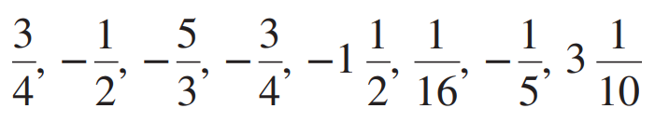
- Arrange these fractions in ascending order.

$$-\frac{5}{3}, -1\frac{1}{2}, -\frac{3}{4}, -\frac{1}{2}, -\frac{1}{5},\frac{1}{16},\frac{3}{4}, 3\frac{1}{10}$$

